## 

DAT 520 Problem Set 3

Michael Surdek

Southern New Hampshire University

**Homework Problems:**Using the example problem as reference, complete the following five problems. Turn in the work and results for each of the five problems. (Note: 4 includes a,b,c and 5 includes a,b,c,d). Note that each problem provides a hint which should guide you through the problem along with the Example Problem as a reference. Post any questions you have to the General Discussion area.

**Problem 1:** You are taking a 10 question multiple choice test. If each question has four choices and you guess on each question, what is the probability of getting one question correct? *[Hint: This is a binomial in the form of 10 choose 1 with p=.25.]*

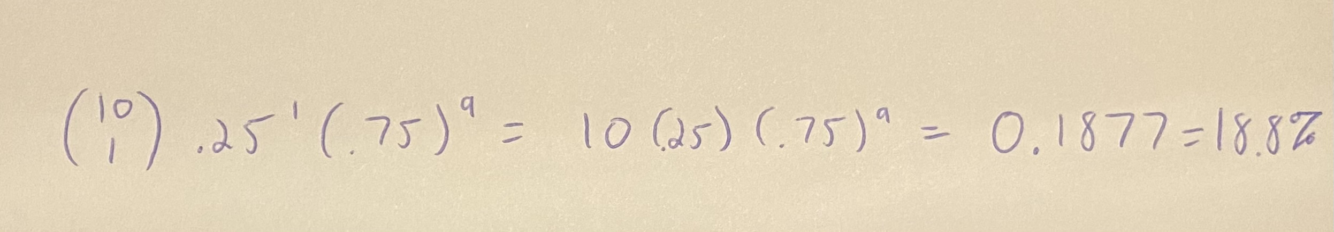

**Problem 2:** What is the probability of getting seven questions correct? *[Hint: This is a binomial as Q1 with modified choose value.]*

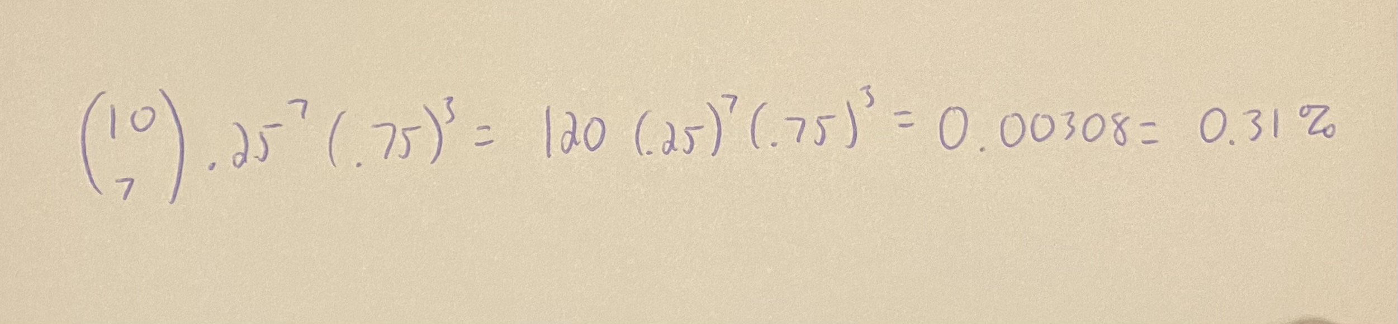

**Problem 3:** What are your chances of answering seven questions correctly if you can reliably eliminate one possible answer from each question? *[Hint: This is a binomial as Q2 with a modified p value.]*

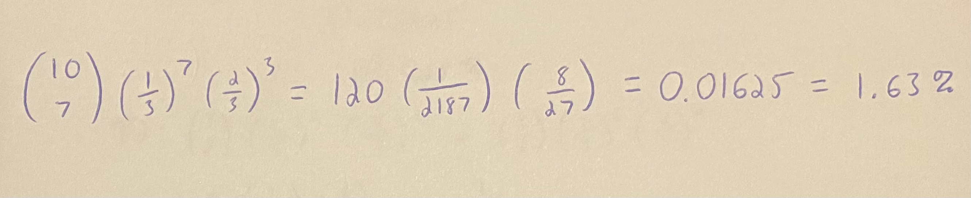

**Problem 4:** Let’s say, instead, that the test is an adaptive test; you get to answer more questions based on your previous success.

This test is structured like this:

First you have to answer three questions and if you are correct on two of them, you get to answer three more questions.

If two of **those** are correct, then you get three final questions, of which you need to get at least two correct to pass the whole test.

The test details are:

The first test, T1, has three multiple choice questions with four possible answers each (*p*=0.25 per question).

The second test, T2, has three multiple choice questions with three possible answers each (*p*=0.33 per question).

The final test, T3, has three questions that are true/false (*p*=0.50 each question).

The test questions are formed as follows:

The questions are in a language you have never seen: a mixture of Navaho, Swahili, Klingon, and Esperanto. So you have to guess on all of the questions and there are no contextual clues to eliminate any answers. This is the first one:

*'Arlogh Qoylu'pu'?*

Moja: Yel kholgo eeah.

Mbili: Floroj kreskas ĉirkaŭ mia domo. Pe'el!

Tatu: La sandviĉo estos manĝota'mo'tlhIngan maH!

Nne: 'Adeez'æ`q eeah.

(The professor sits at the front of class with a giant, sadistic grin while the students throw wads of paper at his head.)

Using the binomial probability rule, the law of total probability and Bayes’ theorem:

1. What is the probability of getting two right on each sub-exam? (T1, T2, and T3, separately.)
2. What are your overall chances of passing the entire exam?
3. What are your chances of passing T3 if you first pass T1 and T2?

### Problem Hint:

Structure your analysis.

Figure out the component probabilities: p(passing test 1), p(passing test 2), p(passing test 3).

Make a table of their proportional contributions of probability to the whole.

Calculate the total probability: p(Total).

Continue using Bayes’ theorem to calculate the probability of passing test 3 conditional on passing tests 1 and 2.

Render your interpretation. Use the interpretation in the example as a template, if you are unsure of what to say.

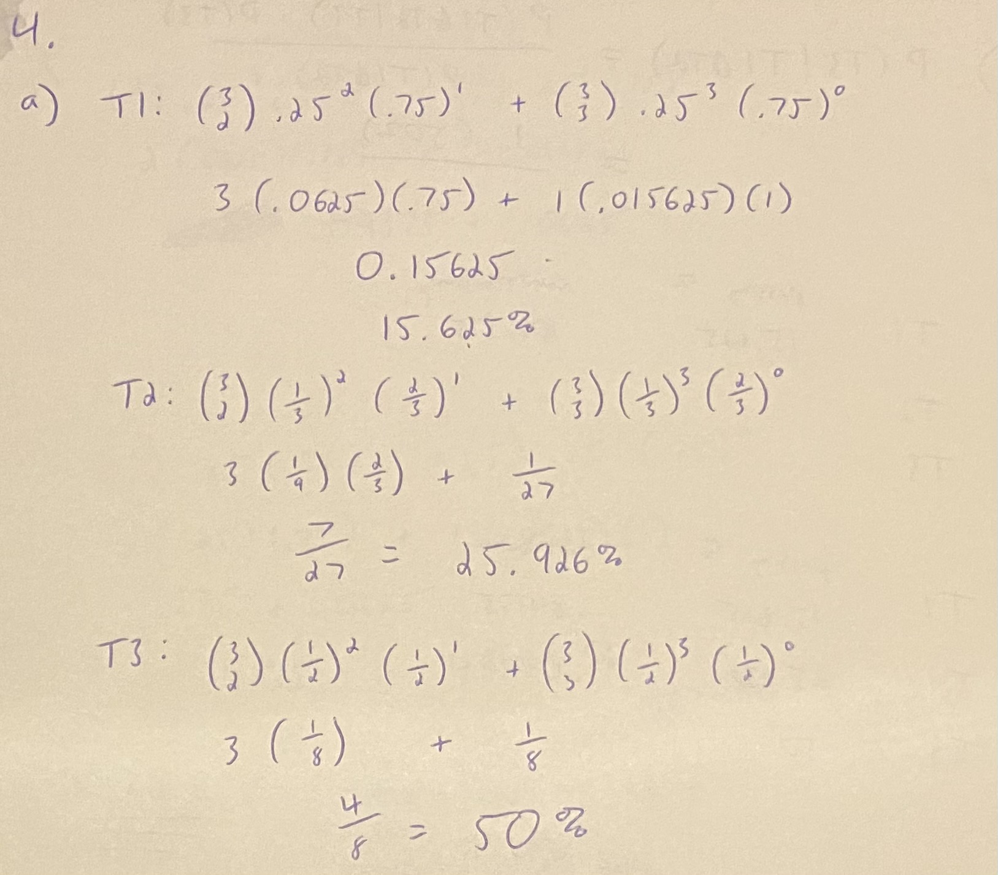

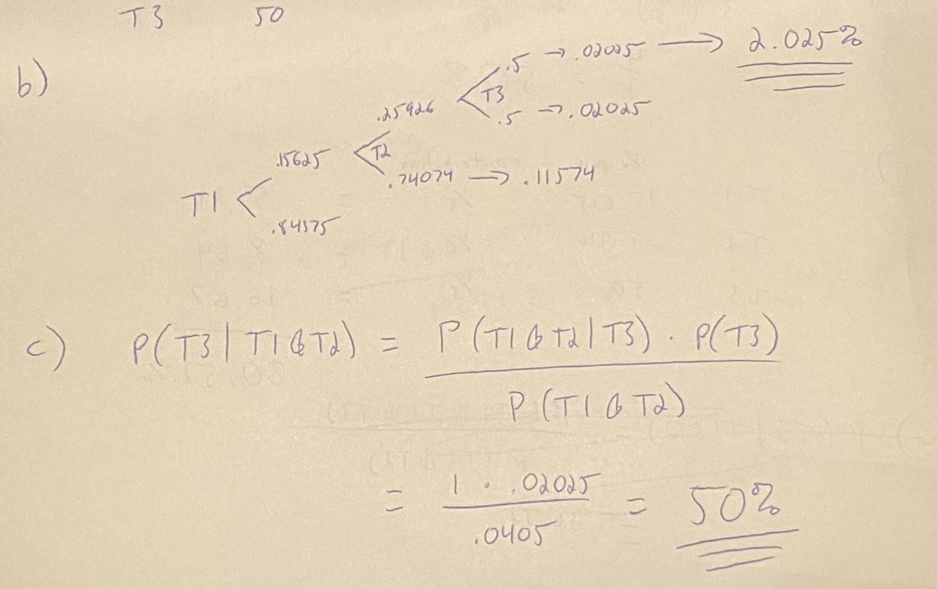

**Problem 5**: Now, let’s say that you know just enough of these obscure languages to translate the first question in T1:

What time is it? (Klingon)

1. (Swahili): From dawn to setting sun. (Navajo)
2. (Swahili): Flowers grow around my house (Esperanto) so all of you may come in. (Klingon)
3. (Swahili): The sandwich will be eaten (Esperanto) because we are Klingons! (Klingon)
4. (Swahili): It’s mid-afternoon. (Navajo) **[correct answer]**

Now the probability of passing T1 has changed because you only have to guess correctly on one of the two remaining questions in the first section, a one-in-two chance.

1. What is the new probability for T1?
2. Now what is the overall probability of passing the entire test?
3. And what is the probability of passing section T3, given that you have already passed sections T1 and T2?
4. The kicker: How do you explain the difference between 4c and 5c? Can you relate this to a larger context about conditional probability and making decisions?

### Problem Hint:

Compute the new probability for T1

Derived the total probability using the new value of T1

Use Bayes theorem with the updated values to compute new conditional probability of passing T3 given you have passed T1 and T2

Consider conditional probability and how T1, T2 and T3 are considered a systems

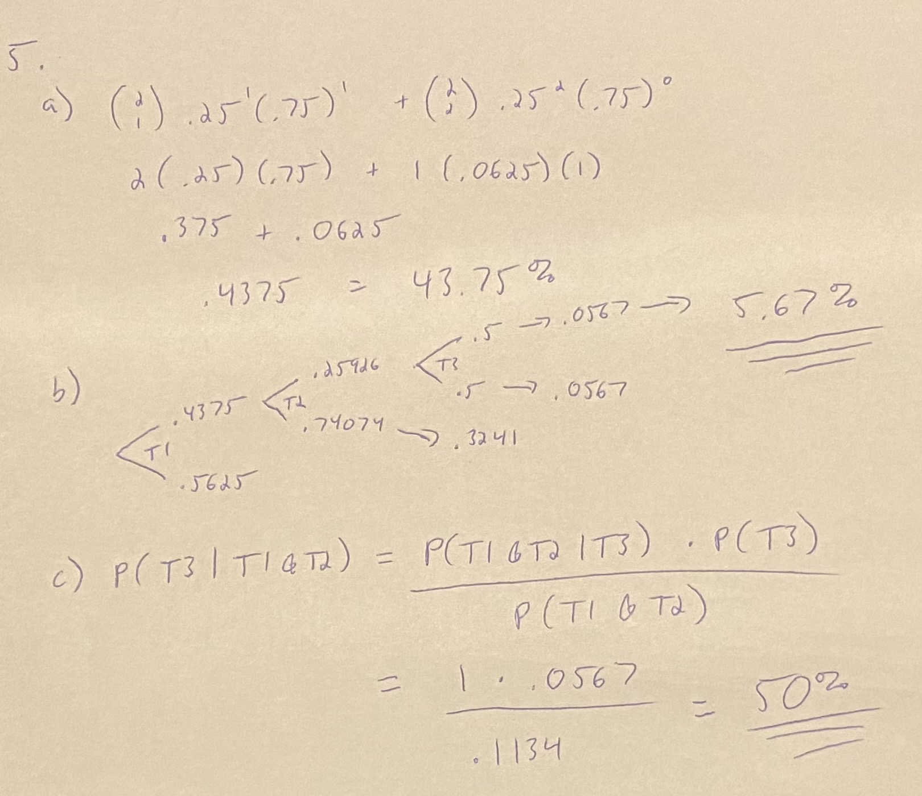

d)

I was unable to come up with a different answer for 4 and 5 c. I am either unsure about how to allocate the contribution percentages of the various portions of the test, or I am misunderstanding one or more of the elements of Bayes’ formula. I was seemingly unsuccessful when I tried doing 4 b and c other ways as shown below. I also do not completely understand the larger context. I know from the fact that this question exists that the conditional probability of T3 would change if the probability of passing T1 changes, but I still do not understand the reason because it seems like the fact that someone passed T1 and T2 has nothing to do with the chances that they’ll pass T3. I fully intend to make time this week to dig deeper and figure out knowledge what I am currently lacking that would help in this problem set, as I am aware of the importance of this concept when it comes to statistical analysis and decision making in particular.

